Reasons for Blowback During Sewer Maintenance Cleaning
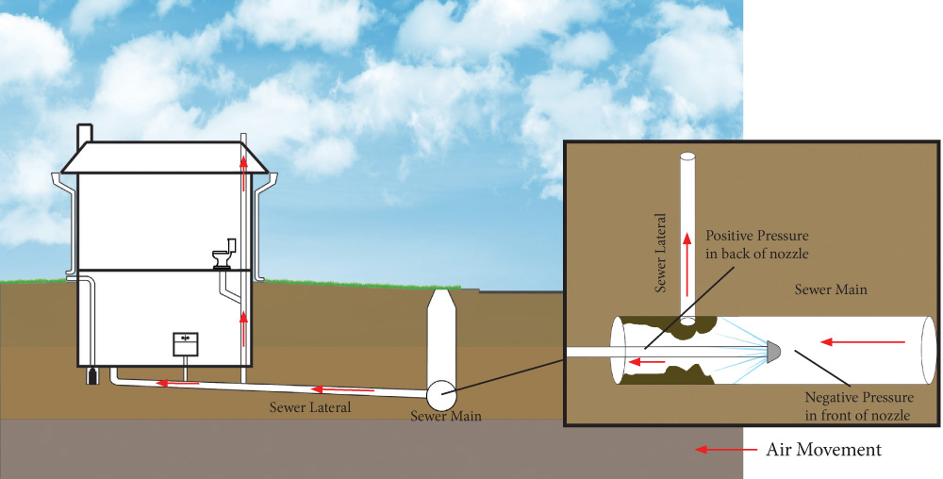
During the sewer maintenance cleaning process, a jet nozzle and hose are inserted into a manhole and water pressure is used to slowly propel the nozzle and hose upstream, typically to the upstream manhole. The pressure is then lowered and the nozzle is pulled back to the first manhole. This process is in accordance with the National Association of Sewer Service Companies (NASSCO) recommended cleaning procedures, and cleans the inside of the sewer mainline of roots, grease, grit, or other debris that builds up over time. In cases where extensive accumulations of debris has occurred, additional cleaning and/or a camera inspection may be warranted. This maintenance lowers the chance of sewer backups and restores flow capacity in the sewer mainline.
During this cleaning process, while the nozzle is propelling itself up the mainline, a negative pressure is created ahead of the nozzle while a positive pressure is created on the back side of the nozzle. Efforts are made to use the least amount of energy required to perform the cleaning of the sewer mainline. The amount of negative pressure will vary with the pump pressure, type of nozzle, and water volume used. As the nozzle moves through the mainline, it passes house laterals in a fraction of a second, causing a rapid change from negative to positive pressure. This positive pressure pushes back into the service lateral line. If there is nowhere for the positive pressure to go (through a properly vented stack) then it will force its way out through the plumbing fixtures or floor drain, thereby creating a blowback. Blowback is an eruption of air and water discharging incorrectly from a plumbing fixture drain.
Blowback can be caused by a plugged vent stack or inadequately designed plumbing. There are many factors which can increase the likelihood of blowback such as elevation, distance of the lateral from the mainline, a debris field in the mainline, etc. One possible solution for customers who have experienced a blowback would be to install a backflow preventer. A properly functioning backflow preventer, installed in the lateral between the structure and the sewer mainline, could reduce the possibility of experiencing another blowback occurrence.
With over 6,775 customer accounts, 110 miles of sanitary sewer mainline, and 10 lift stations, the District has found that blowback instances are rare. The District is committed to maintaining its sewer lines to reduce the likelihood of backups while doing our best to minimize blowbacks. Please contact us at (509) 884-2484, with questions or concerns. Our 24-hour emergency telephone number is (509) 670-3900.

